ADS instruction Manual

**Main Menu**

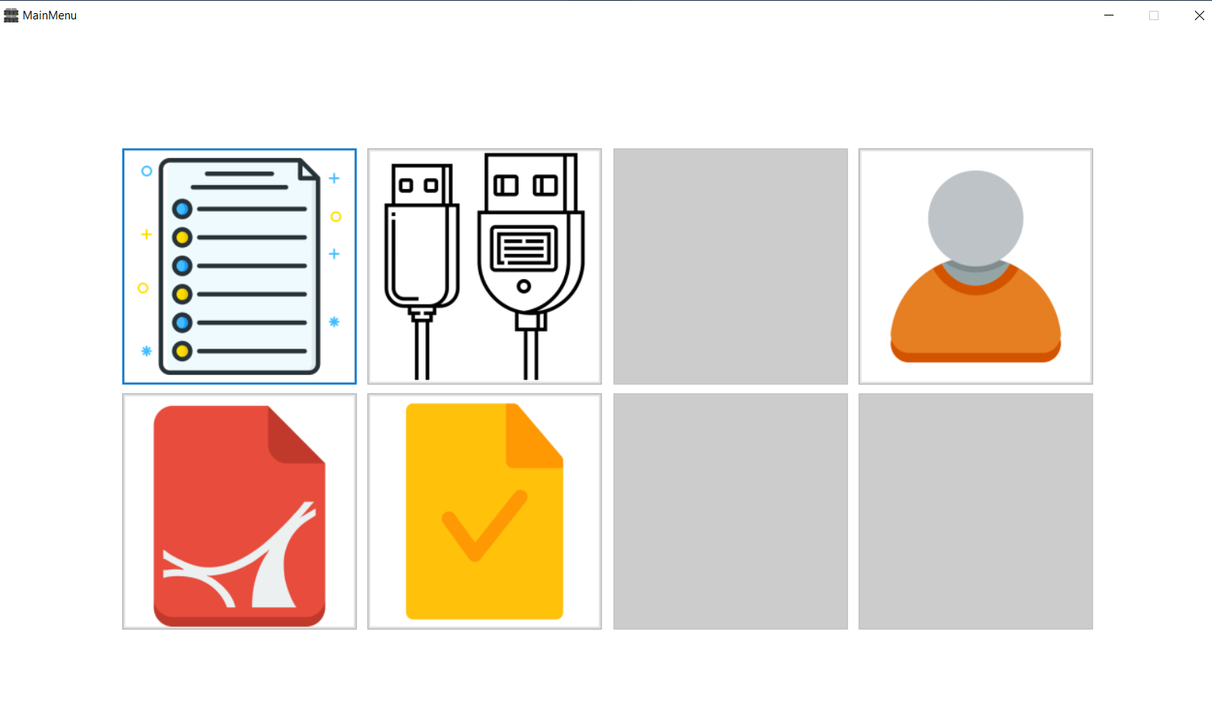

From Top – left to right

1. Generate Dissolution report
2. Device status and control
3. Blank
4. User management

From bottom – left to right

1. View report
2. Audit status
3. Blank
4. Blank

**Generate Dissolution report**

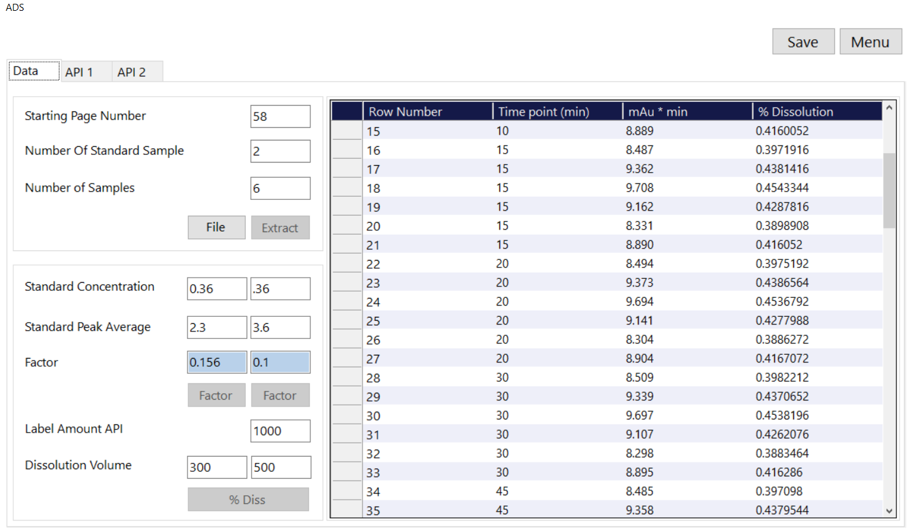

Input fields

1. Starting Page number : Enter the page number where the mAu*min data for all the time points are populated. In the below **report the page number is 58.**

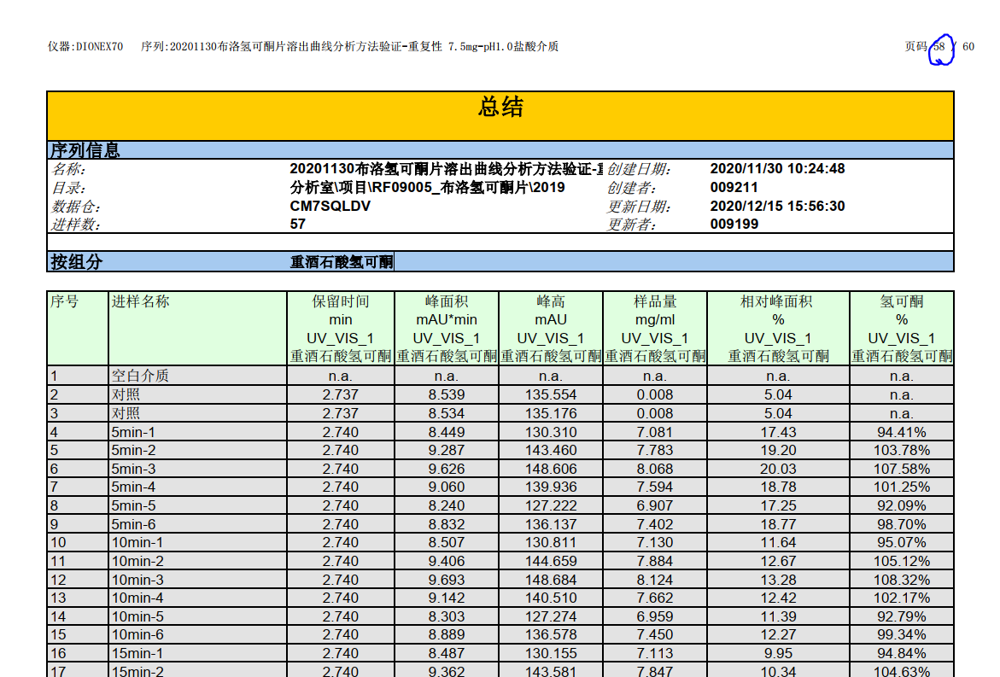

1. Number of standard samples: The number of standards used in the process. **In the below report it is 2.**

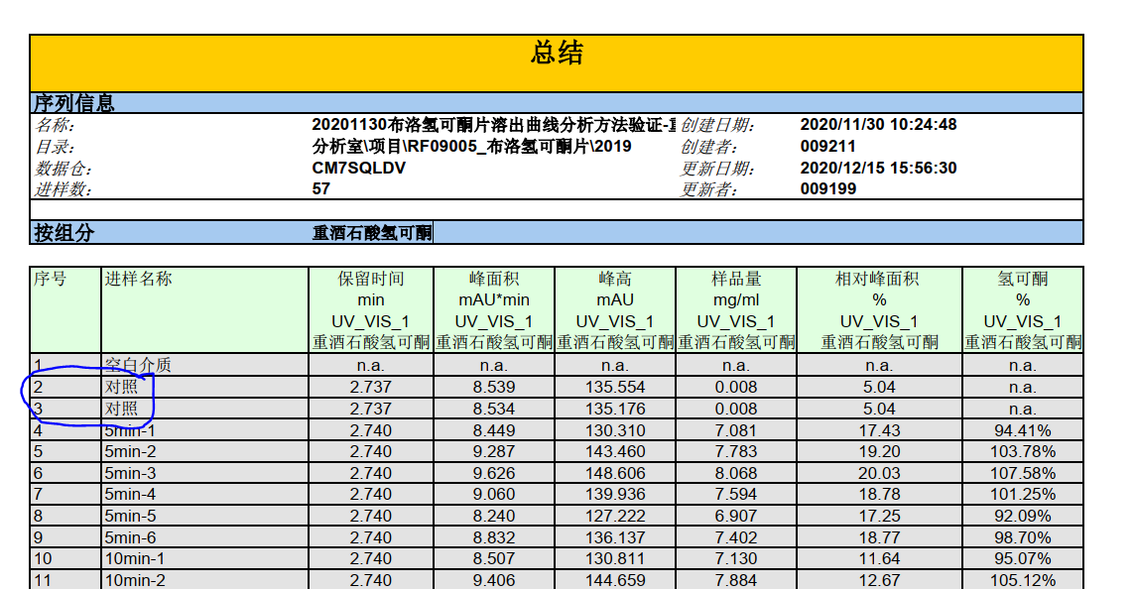

1. Number of samples: The number of samples in each time point. **The below HPLC report has 6 samples.**

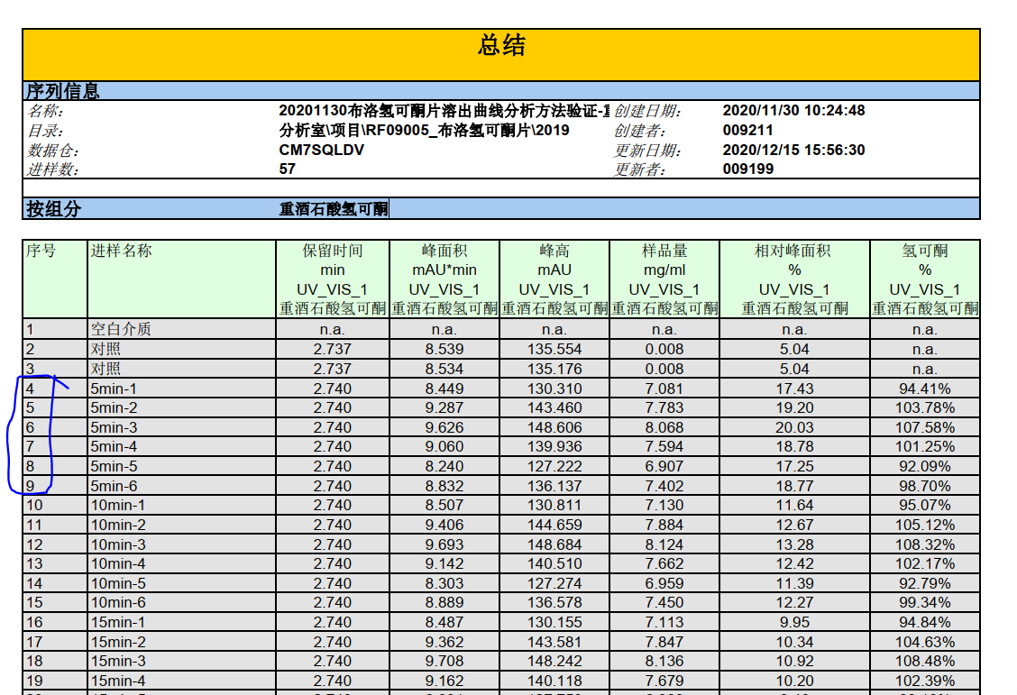

1. Click on “File”, Go to the folder where the Thermo Fisher HPLC report is stored. Click on Open.
2. Click on “Extract”. The data will be displayed in the table on the right side.
3. Standard Concentration: The standard concentration used. If two API’s are in the report, enter both the concentration.
4. Standard Peak Average: Enter the standard peak area average for the API. If two API’s are in the report, enter both the standard peak area average.
5. Click on factor. The software will calculate the factor value.
6. Label amount API: Enter the label amount API used.
7. Dissolution volume: Enter the dissolution volume used. If two API’s are in the report, enter both the dissolution volume used.
8. Click on % diss to calculate the dissolution volume. The software will generate the graphs( if two API, then two graphs will be generated).